Mission:

To create a culture in which traffic fatalities and serious injuries are no longer acceptable through the integrated application of [education](http://www.minnesotatzd.org/four/education/index.html), [engineering](http://www.minnesotatzd.org/four/engineering/index.html), [enforcement](http://www.minnesotatzd.org/four/enforcement/index.html) and [emergency medical and trauma services.](http://www.minnesotatzd.org/four/emergency/index.html) These efforts will be driven by data, best practices and research.

Values:

* Continuous improvements,
* Engage partners and
* Evidence-based approaches.

The Northwest Minnesota Toward Zero Deaths (TZD) program began in 2008. The counties involved include: Beltrami, Clearwater, Hubbard, Kittson, Lake of the Woods, Marshall, Norman, Pennington, Polk, Red Lake, and Roseau.

The leading cause of deaths and severe injuries in northwest Minnesota include:

* Alcohol,
* Distraction,
* Speed and
* Lack of Seatbelt use.

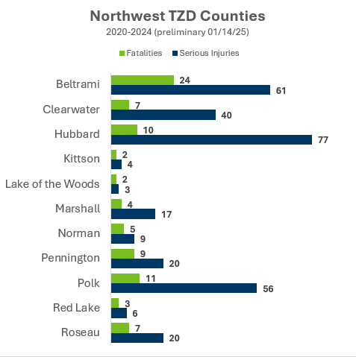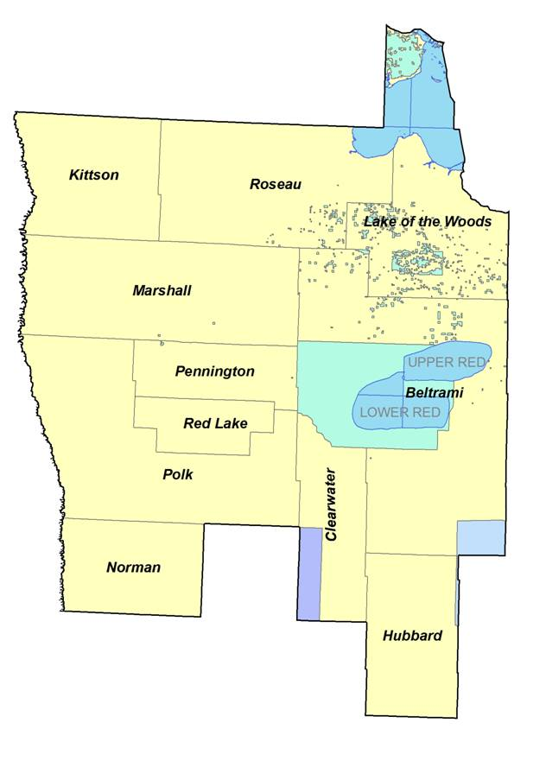

The leading factors in crashes resulting in deaths and severe injuries include:

* Careless/reckless driving
* **Failure to keep in proper lane**

The Northwest Minnesota TZD program is led by a steering committee comprised of the “4 Es:”

* Enforcement
* Engineering
* Education
* Emergency Medical and Trauma Services.