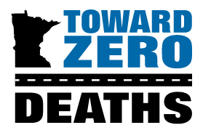
2025 Traffic Safety Innovation Award

Deadline June 26, 2025 at 5:00 p.m. to tzd@umn.edu

The Traffic Safety Innovation Award recognizes organizations for new or creative traffic safety solutions that help save lives on Minnesota roads. The award is given for work on specific actions, initiatives, programs, best practices, marketing campaigns, partnerships, or products.

WHO ARE YOU NOMINATING? Nominee Information (please attach additional pages as needed)
Organization Nominating
Primary Contact Name
Title
Address
City, State, Zip Code
Office Phone
Cell Phone
E-Mail

- Describe how the specific traffic safety action, initiative, program, best practice, marketing campaign, partnership or product has provided Minnesota with new, innovative and creative ideas to reduce the number of traffic fatalities on Minnesota roads.
- Are there any other noteworthy accomplishments that do not specifically apply to the questions above that you would like the selection committee to consider? If yes, please briefly describe.

WHO ARE YOU? Nominator Information
Primary Nominator Name
Title
Organization
Office Phone
Cell Phone
E-Mail (correspondence will be sent to this email only)
LIST ADDITIONAL NOMINATORS’ NAMES BELOW (optional)

