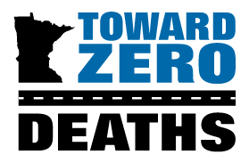
2025 TZD Star Awards

Deadline June 26, 2025 at 5:00 p.m. to tzd@umn.edu

The Toward Zero Deaths Star Awards are given to recognize excellence in enforcement, emergency medical and trauma services, education, engineering, child passenger safety, and for the legal professional. Award recipients have demonstrated exceptional creativity, leadership, and organizational skills and the ability to successfully motivate and collaborate with others in efforts to move toward zero deaths on Minnesota’s roads.

WHO ARE YOU NOMINATING? Nominee Information (please attach additional pages as needed)
Name
Title
Organization
Address
City, State, Zip Code
Office Phone
Cell Phone
E-Mail

- Which Star Award is this individual being nominated for?

€ Enforcement | € Emergency Medical and Trauma Services | € Engineering
€ Child Passenger Safety | € Legal Professional | € Education
- How has the nominee helped motivate and/or collaborate with others by using creativity and leadership to move Toward Zero Deaths on Minnesota roads?

- Please note any connections the nominee has with TZD (for example, attending TZD events or participating in a TZD coalition).

- Are there any other noteworthy accomplishments that do not specifically apply to the questions above that you would like the selection committee to consider? If yes, please briefly describe.

WHO ARE YOU? Information
Primary Nominator Name
Title
Organization
Office Phone
Cell Phone
E-Mail (correspondence will be sent to this email only)
LIST ADDITIONAL NOMINATORS’ NAMES BELOW (optional)

