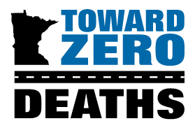
2025 TZD Media Award

Deadline June 26, 2025 at 5:00 p.m. to tzd@umn.edu

The Toward Zero Deaths Media Award is given to recognize an individual or organization in the media that has demonstrated excellence in raising public awareness about traffic safety. Recipients have gone beyond the typical news story and shown a commitment to reducing traffic fatalities and serious injuries in Minnesota.

WHO ARE YOU NOMINATING? Nominee Information (please attach additional pages as needed)
Name
Title
Organization
Address
City, State, Zip Code
Office Phone
Cell Phone
E-Mail

- How has the nominee portrayed excellence in raising public awareness about traffic safety by going beyond the typical news story? How do they continue to show commitment to reduce traffic fatalities and serious injuries on Minnesota roads?
- Please note any connections the nominee has with TZD (for example, attending TZD events or participating in a TZD coalition).

- Are there any other noteworthy accomplishments that do not specifically apply to the questions above that you would like the selection committee to consider? If yes, please briefly describe.

- Optional: You are encouraged to include one or more news stories from the nominee that support their nomination.

WHO ARE YOU? Nominator Information
Primary Nominator Name
Title
Organization
Office Phone
Cell Phone
E-Mail (correspondence will be sent to this email only)
LIST ADDITIONAL NOMINATORS’ NAMES BELOW (optional)

