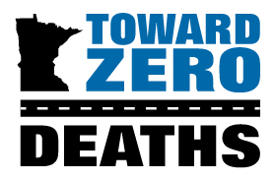
2025 Emerging
Leader Award

Deadline June 26, 2025 at 5:00 p.m. to tzd@umn.edu
The Emerging Leader Award was established to recognize leaders who are students that display excellence in increasing traffic safety awareness. Recipients have demonstrated creativity, vision, leadership, and organizational skills, as well as the ability to successfully motivate and influence their peers in efforts to move toward zero deaths on Minnesota roads.

WHO ARE YOU NOMINATING? Nominee Information (please attach additional pages as needed)
Name
Title
Organization
Address
City, State, Zip Code
Office Phone
Cell Phone
E-Mail
School Attending
Expected Graduation Year

- How does the nominee's work and/or actions demonstrate creativity, vision, leadership, and organizational skills, as well as the ability to successfully motivate and influence younger people in efforts to move toward zero deaths on Minnesota’s roads?

- Please note any connections the nominee has with TZD (for example, attending TZD events or participating in a TZD coalition).

- Are there any other noteworthy accomplishments that do not specifically apply to the questions above that you would like the selection committee to consider? If yes, please briefly describe.

WHO ARE YOU? Nominator Information
Primary Nominator Name
Title
Organization
Office Phone
Cell Phone
E-Mail (correspondence will be sent to this email only)
LIST ADDITIONAL NOMINATORS’ NAMES BELOW (optional)

