Mission
To move southwest Minnesota toward zero deaths on our roads, using education, enforcement, engineering, and emergency medical and trauma services.

Goal 1 – Reduce TZD Fatality and Serious Injuries
To continuously decrease traffic related fatalities and serious injuries in Southwest Minnesota from the past five-year average of 30 fatalities and 101 serious injuries (2019-2023).

Objectives
- To continuously increase regional seatbelt use rates. Southwest Region rate was 87.1% in 2023, which is down from 90.5% in 2021. As a region, our long-term goal is to achieve a 100% usage rate. Our short-term goal is to see an increase in the usage rate each year.

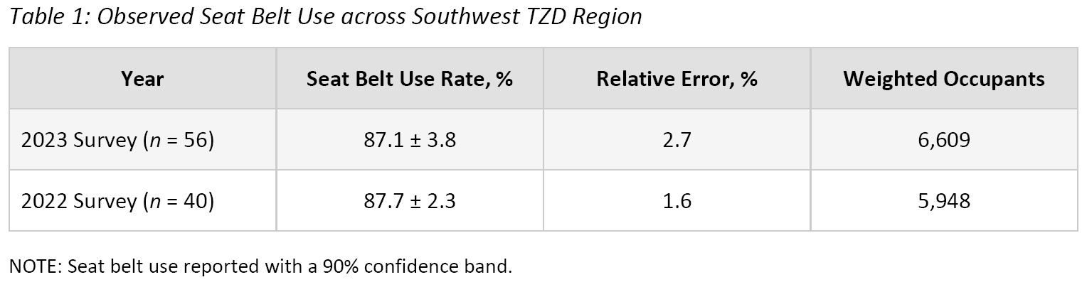
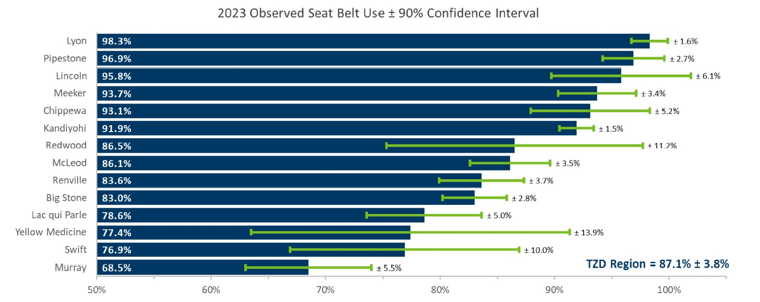

- To examine the characteristics of the unbelted fatalities and serious injuries. The 2019-2023 5-year average in Southwest Minnesota was 10 unbelted fatalities and 19 serious injuries.
- To continuously decrease the following:
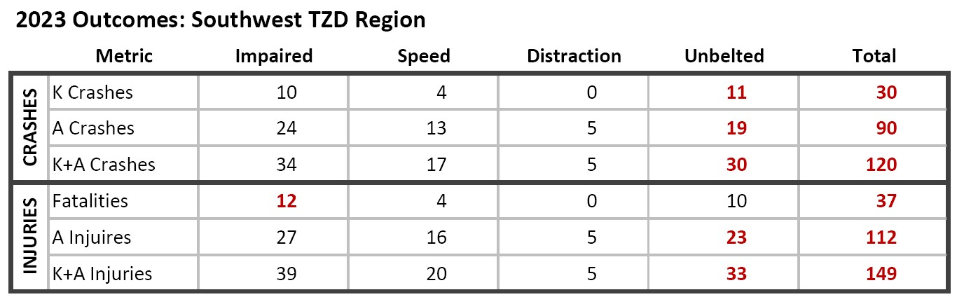
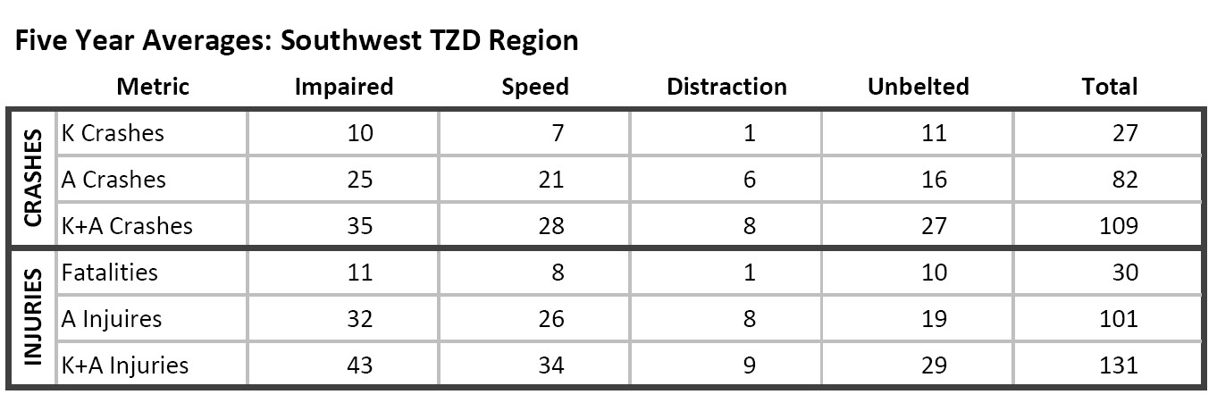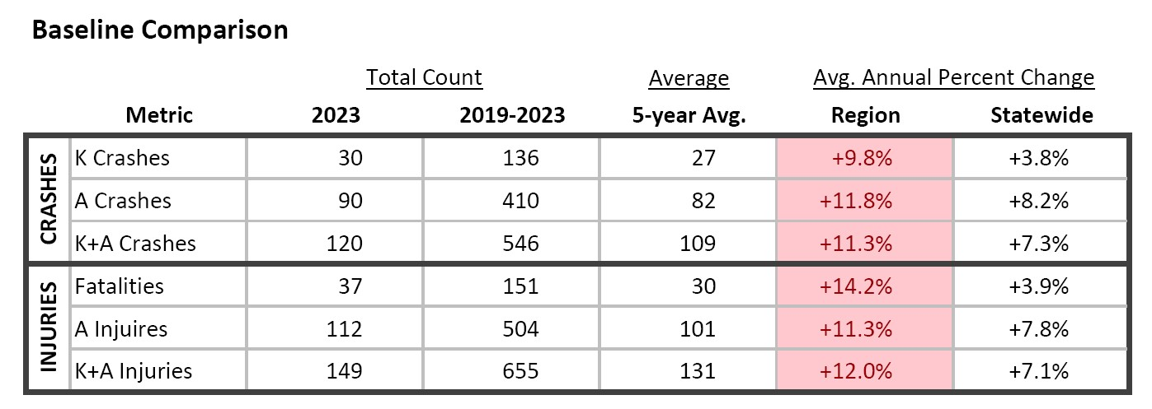
*Data are Preliminary
Note: a crash may have more than one of the above listed or additional contributing factors.
Region Goal 2 – TZD Partnership Goals
To continuously increase TZD awareness and partnerships across southwest Minnesota for both the public and traffic safety professionals.

- Establish the vision of TZD as a priority for all region, county, city (government agencies)
- Engage local government involvement in TZD steering committee and workshops
- Educate/promote traffic safety awareness of city/county officials
- Promote city/county employee education/policies that facilitate the TZD vision
(Activities: Recruitment of city and county to attend TZD event, giving TZD presentations to boards/councils, mailings/connections to Network of Employers for Traffic Safety (NETS)

- Create and strengthen partnerships in the region
  - Engage stakeholders
  - Develop networking relationships
  - Recruit membership of the TZD partnership

(Activities: EMS Conference booth/presentation, regional workshop, web, calendar, statistics, workshop, orientation)

- Promote and implement effective traffic safety initiatives in the region
  - Develop and distribute resource materials
  - Provide enforcement wave support in community
  - Promote evidence based countermeasures
  - Collect data and statistics within region
  - Implement best practices within region

(Activities: web, brochure, one-pagers, presentations, news advisories, workshop, seatbelt observational survey and omnibus survey, media messaging and media events, news releases re: activities woven into existing messages, worksite education and policy development, parent component to drivers education, sober cab development, youth enforcement and education activities)

