Mission

To create a culture in which traffic fatalities and serious injuries are no longer acceptable through the integrated application of [education](http://www.minnesotatzd.org/four/education/index.html), [engineering](http://www.minnesotatzd.org/four/engineering/index.html), [enforcement](http://www.minnesotatzd.org/four/enforcement/index.html) and [emergency medical and trauma services.](http://www.minnesotatzd.org/four/emergency/index.html) These efforts will be driven by data, best practices and research.

Values

* Continuous improvements,
* Engage partners and
* Evidence-based approaches

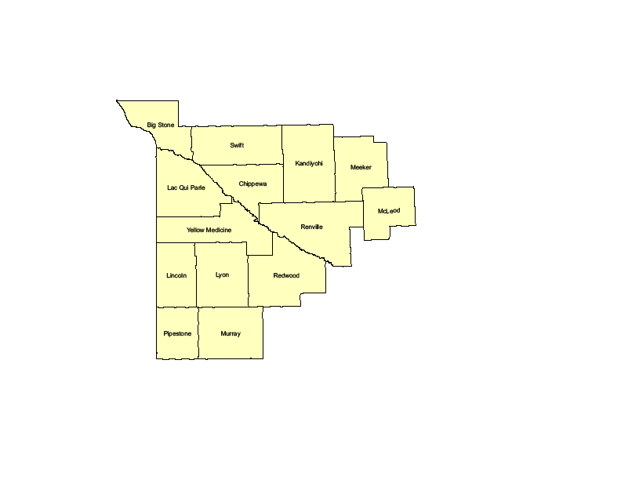

The Southwest Minnesota Toward Zero Deaths (TZD) program began in 2007. The counties involved include: Big Stone, Chippewa, Kandiyohi, Lac qui Parle, Lincoln, Lyon, McLeod, Meeker, Murray, Pipestone, Redwood, Renville, Swift and Yellow Medicine.

The leading cause of deaths and severe injuries in southwest Minnesota include:

* Impairment
* **Unbelted**

**Southwest Minnesota Fatals and Serious Injuries**by County (2019-2023*)

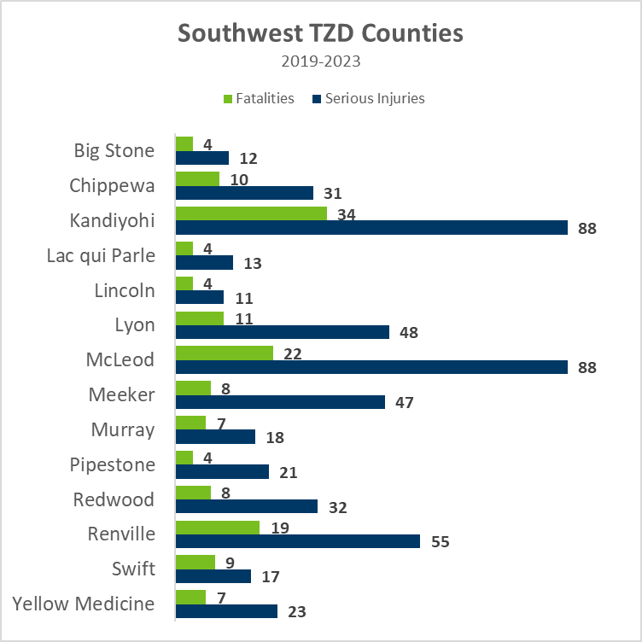

*Data are Preliminary

The leading type of crash resulting in deaths and

severe injuries include:

* Run-off Road
* Intersection

The Southwest Minnesota Toward Zero Deaths program is led by a Steering Committee comprised of the “4 Es:”

* Enforcement
* Engineering
* Education
* Emergency Medical and Trauma Services