Mission:
To create a culture for which traffic fatalities and serious injuries are no longer acceptable through the integrated application of education, engineering, enforcement, and emergency medical and trauma services. These efforts will be driven by data, best practices, and research.
Values:
- Continuous Improvements
- Engaged Partners
- Evidence-based Approaches
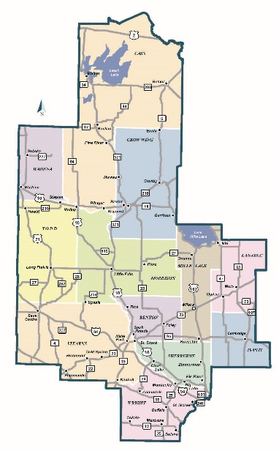
The East Central Minnesota Toward Zero Deaths (TZD) program has been developing for five years. The counties involved include Benton, Cass, Crow Wing, Isanti, Kanabec, Mille Lacs, Morrison, Sherburne, Stearns, Todd, Wadena, and Wright.

The leading causes of death and severe injuries in East Central Minnesota include:
- Lack of Seatbelt Use
- Impaired Driving
- Speed and Aggressive Driving
- Inattentive Driving
East Central Minnesota Fatals and Serious Injuries by County (2019-2023)

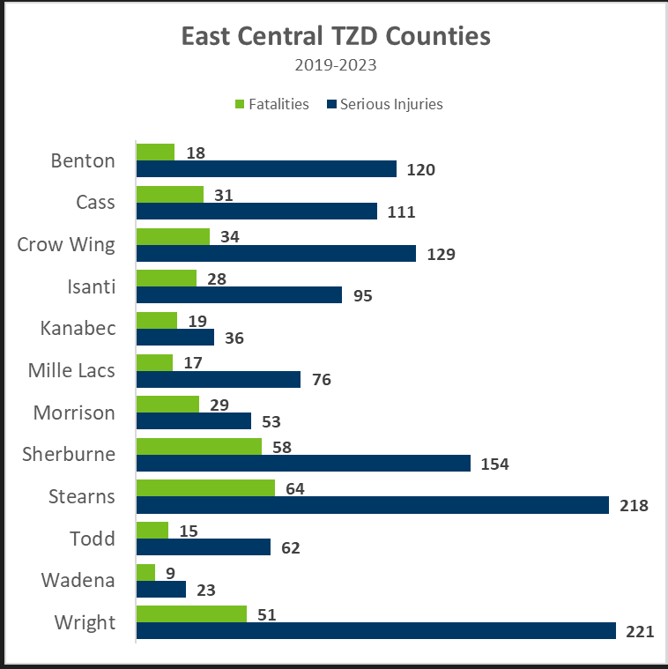
The leading types of crash resulting in deaths and severe injuries include:
- Run off the Road
- Impaired Driving
The East Central Minnesota TZD program is led by a steering committee comprised of the “4 Es:”
- Enforcement
- Engineering
- Education
- EMS / Emergency Medical & Trauma Services

